## Project: Flipkartflipkart photo.png

**The** primary goal of an e-commerce site is to sell goods online. This project deals with developing an e-commerce website for Online product sale. It provides the user with a catalog of different product available for purchase in the store. In order to facilitate online purchase a shopping cart is provided to the user.

**1. HOME PAGE:**

* Header
* Brand Name
* Search bar_ Input button
* Login_ User
* Become a seller_ Products
* More_ Notification preference, customer care etc…
* Cart_add product to wishlist
* Top offer deals
* Mobiles
* Grocery
* Fashion
* Electronics
* Home
* Appliances
* Sliders with Offers
* Deals of the Day
* Suggested for You
* Footer
* About
* Contact
* Help
* Social

**2. LISTING PAGE:**

* Filters
* Categories
* Price scale
* Discount
* Customer Rating
* Offers
* Availability
* Item’s List
* Selected product name
* Sort
* Price-Low to High
* Price-High to Low
* Newest First
* Each item in separate division
* Image of item and name
* Price tag with offer%

**3. Detailing Page**:

* Product Image
* Add to cart
* Buy Now
* Product Name
* Ratings & Reviews
* Cost of Product
* Available Bank Offers

Payment for selected product

In the below page the outlook the project site

Home page outlook:

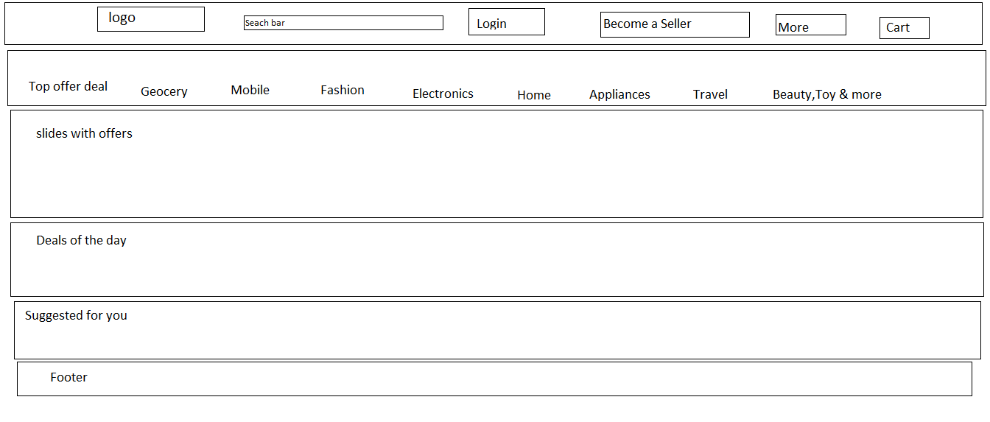

Listing page outlook:

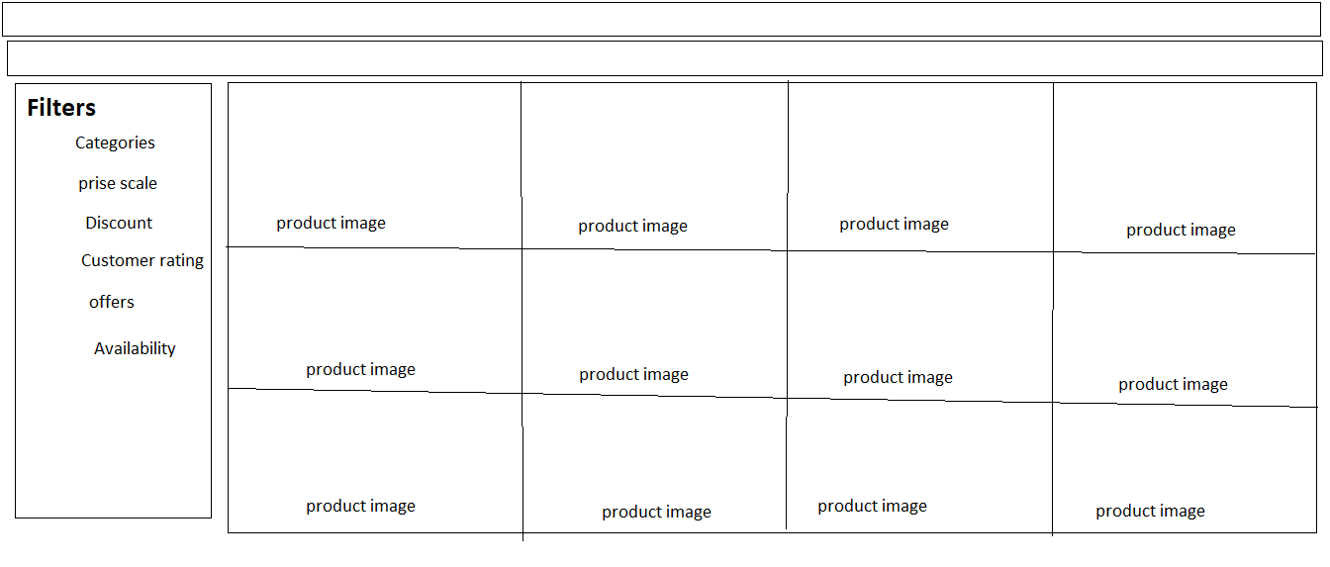

**Detailing page:**

